# **Document: Org Chart & Team**

## 

## **Sauce & Spoon Organizational Chart**

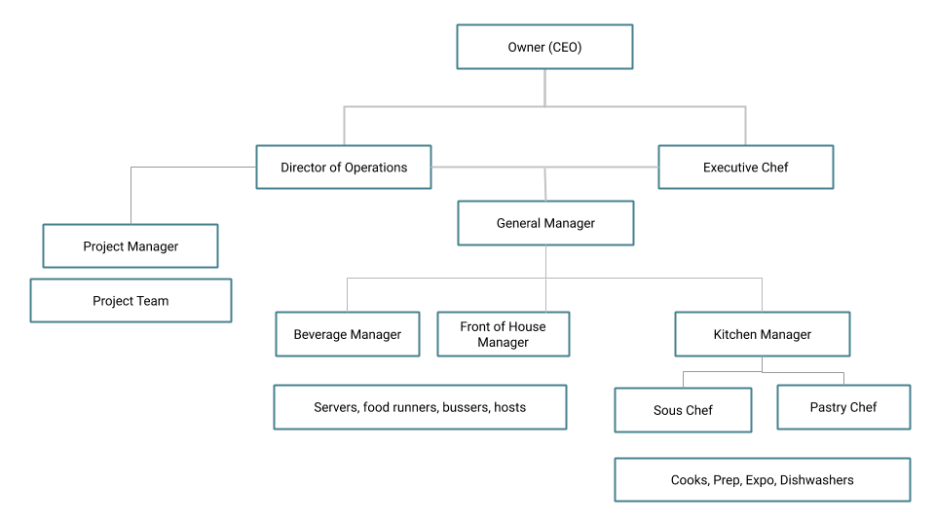

An organizational chart. At the top of the chart there is the Owner, then Director of Operations and Executive Chef. Director of Operations oversees Project Manager and the Project Team and then General manager. The general manager oversees Beverage Manager, Front of House Manager and Kitchen Manager. Below the Front of House Manager and Beverage Managers are the Servers, Food Runners, Bussers and Hosts. The Kitchen Manager over sees the Sous Chef and Pastry Chef. Below the Sous Chef and Pastry Chef are the Cooks, Prep Cooks, and Dishwashers.

## **Sauce & Spoon Project Team**

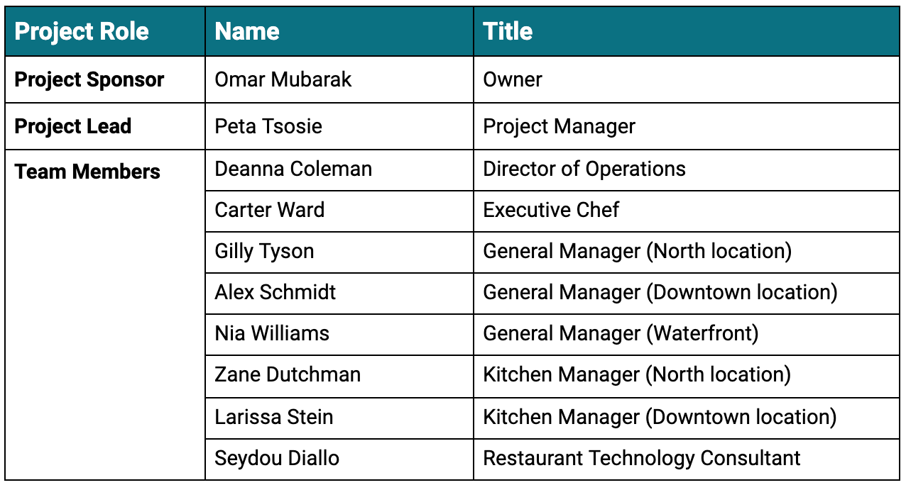



## **Project Team Bios**

**Omar Mubarak, Owner**: Omar Mubarak is the owner and CEO of Sauce & Spoon, and opened the first Sauce & Spoon five years ago. Today he’s the manager of the Sauce & Spoon restaurant group, which has multiple locations, and maintains an incredibly busy schedule. As the owner and CEO, Omar is responsible for the overall direction, profitability, and reputation of the restaurant group. He is the most senior stakeholder at Sauce & Spoon and supports initiatives aimed at advancing the restaurant’s mission and vision.

**Deanna Coleman, Director of Operations**: Coming from hedge fund management, Deanna’s style is to dive into projects and work directly with the people involved. She leads the vision for Sauce & Spoon initiatives and has high expectations for excellence. As director of operations, Deanna is responsible for daily communication across different teams, and ultimately for ensuring that ingredients are sourced with integrity at each location. She also oversees the restaurant managers and works with them on interviewing, hiring, and training new employees.

**Carter Ward, Executive Chef**: Carter started his career as a military chef. He has worked hard to bring his vision for Sauce & Spoon’s sustainable sourcing and scratch-to-table cuisine to life. As executive chef, Carter is the visionary and has the final say on all menu choices. He runs a tight kitchen and is responsible for overseeing all other chefs employed by the restaurant.

**Gilly Tyson, General Manager (North)**: Gilly Tyson manages Sauce & Spoon’s business district location. She has been in the restaurant business for her whole career, starting as a waitress. The staff love and respect her down-to-earth personality. She’s a great resource for training and providing input on general restaurant operations. As general manager, Gilly is responsible for hiring and training the North location restaurant staff, ordering all the restaurant’s supplies, and talking to customers to ensure that they are happy with their service.

**Alex Schmidt, General Manager (Downtown)**: Alex Schmidt manages Sauce & Spoon’s bustling downtown location. They are somewhat new to the role, having come from retail management at a large home improvement chain. But they've adapted quickly to the restaurant industry, largely due to the quality of Gilly’s training. As general manager, Alex is responsible for hiring and training the Downtown location restaurant staff, ordering all the restaurant’s supplies, and talking to customers to ensure that they are happy with their service.

**Nia Williams, General Manager (Waterfront)**: Nia Williams began her restaurant career in high school as a hostess, and continued to work her way up to management during college. Before taking the general manager position at Sauce & Spoon, she tended bar at a luxury hotel. She’s passionate about the restaurant industry and works hard to support her staff and the overall success of the company. Nia is responsible for hiring and training the Waterfront location restaurant staff, ordering all the restaurant’s supplies, and talking to customers to ensure that they are happy with their service.

**Zane Dutchman, Kitchen Manager (North)**: Zane Dutchman was a sous chef before becoming kitchen manager. They’re excited for the opportunity, but are still learning the ropes—mostly from Larissa. As kitchen manager, Zane is responsible for overseeing the day-to-day back of house operations and administrative tasks at the North location. They are also responsible for controlling costs and managing labor.

**Larissa Stein, Kitchen Manager (Downtown)**: Larissa Stein is fairly new to Sauce & Spoon, but in her last position she managed a fast-paced kitchen at a Michelin-star restaurant in New York City. She loves the excitement of restaurant work, and keeps a close eye on operations. As kitchen manager, Larissa is responsible for overseeing the day-to-day back of house operations and administrative tasks at the Downtown location. She is also responsible for controlling costs and managing labor.

**Seydou Diallo, Restaurant Technology Consultant**: Seydou Diallo has a background in tech support and recently transitioned to a consulting role for the restaurant industry. This is his first major project, so he’s excited to see the launch—and to prove himself to his boss. As a restaurant technology consultant, Seydou helps restaurants like Sauce & Spoon implement cost-effective, easy-to-use, integrated technology systems. He determines client needs, highlights where technology can streamline processes and improve the guest experience, and then designs and implements appropriate solutions.